https://chatgpt.com/c/6a439edf-7d18-83e8-ae7c-ffc6d796d9b7

Talent Management Module
Based on the provided Talent Management scope covering Recruitment, ATS, Interviews, Offers, Onboarding, Performance, Compensation, Mobility, Succession, and Offboarding workflows, the module should function as a complete employee lifecycle management system.

1. Information Architecture
Talent Management
│
├── Talent Dashboard
│
├── Recruitment
│ ├── Requisitions
│ ├── Job Openings
│ ├── Candidate Pipeline
│ ├── Interviews
│ ├── Offers
│
├── Onboarding
│ ├── Preboarding
│ ├── New Hire Journeys
│ ├── Probation Tracking
│
├── Performance
│ ├── Goals & KPIs
│ ├── Review Cycles
│ ├── Appraisals
│ ├── Calibration
│
├── Compensation
│ ├── Salary Bands
│ ├── Increment Cycles
│ ├── Bonus Reviews
│
├── Mobility & Succession
│ ├── Internal Jobs
│ ├── Promotions
│ ├── Transfers
│ ├── Successor Pools
│
├── Offboarding
│ ├── Resignations
│ ├── Clearances
│ ├── Exit Interviews
│
├── Administration
│ ├── Templates
│ ├── Workflows
│ ├── Permissions
│ ├── Integrations
│
└── Audit & Activity

2. Navigation Structure

Primary Navigation
Left Sidebar
- Dashboard
- Recruitment
- Onboarding
- Performance
- Compensation
- Mobility & Succession
- Offboarding
- Administration
- Audit Activity

Secondary Navigation
Top Context Tabs
Examples:
Recruitment
- Requisitions
- Jobs
- Candidates
- Interviews
- Offers
Performance
- Goals
- Reviews
- Appraisals
- Calibration

3. Primary Screen Layout

Section 1 — Module Header

Components
Module Title
Talent Management
Description
Manage the complete talent lifecycle from hiring to offboarding.
Breadcrumb
Home → Talent Management
Global Search
Search:
- Candidate
- Employee
- Requisition
- Job Opening
- Review Cycle
- Promotion
- Succession Plan
Global Actions
- Import
- Export
- Assign
- Configure
Primary CTA
- Create New
Dropdown:
- Requisition
- Job Opening
- Candidate
- Review Cycle
- Succession Plan
- Internal Posting
- Exit Case
Access Filters
- Business Unit
- Department
- Location
- Grade
- Employment Type

4. Summary Area
Executive Snapshot Section

Status Cards

Open Positions
- Total Open
- Critical Open

Candidate Pipeline
- Applied
- Screening
- Interview
- Offer

Onboarding
- Preboarding Pending
- Active Onboarding
- Probation Due

Performance
- Active Reviews
- Pending Reviews
- Completed Reviews

Mobility
- Internal Applications
- Transfers
- Promotions

Offboarding
- Resignations
- Notice Period
- Clearance Pending

Progress Indicators

Hiring Progress
Requisition → Screening → Interview → Offer → Hire

Review Cycle Progress
Launch → Self Review → Manager Review → Calibration → Closed

Onboarding Completion
Checklist Completion %

5. Action Bar

Primary Actions
- Create Requisition
- Publish Job
- Add Candidate
- Schedule Interview
- Generate Offer
- Launch Review Cycle
- Open Internal Vacancy
- Initiate Exit

Secondary Actions
- Duplicate Record
- Assign Reviewer
- Upload Documents
- Download Templates
- View History

Bulk Actions
- Assign Recruiter
- Move Stage
- Send Communication
- Change Status
- Export Selected
- Archive Records

6. Main Workspace
The workspace should support multiple operational views.

A. Table View (Default)
Used across all entities.
Columns vary by context.
Example: Candidates
Candidate | Position | Source | Stage | Owner | Updated
Features:
- Sorting
- Grouping
- Column Configuration
- Sticky Headers
- Bulk Selection

B. Kanban Board View
Ideal for ATS Pipeline.
Columns:
- Applied
- Screened
- Assessment
- Interview
- Offer
- Hired
- Rejected
Cards show:
- Candidate
- Position
- Interview Date
- Recruiter

C. Timeline View
Used for:
- Hiring Plan
- Onboarding
- Review Cycles
- Succession Plans

D. Calendar View
Used for:
- Interviews
- Review Deadlines
- Offer Expiry
- Onboarding Milestones

E. Split Detail Workspace
--------------------------------------------------
| List/Grid Area | Detail Panel |
--------------------------------------------------
Allows rapid review without navigation loss.

7. Record Details Area
Opening a record displays a structured profile.

Overview
Record Summary
Examples:
Candidate
- Name
- Applied Role
- Current Stage
- Recruiter
- Status
Employee
- Department
- Grade
- Manager
- Performance Cycle

Attributes
Dynamic fields by record type.
Examples:

Candidate
- Source
- Experience
- Notice Period
- Skills
- Location

Employee
- Position
- Grade
- Joining Date
- Mobility Status

Related Information

Recruitment
- Interviews
- Assessments
- Offers

Employee
- Goals
- Reviews
- Compensation
- Promotions

Attachments
- Resume
- Offer Letter
- Contracts
- Certifications
- Exit Documents

Activity History
Chronological log.
Created
Updated
Approved
Assigned
Moved Stage
Closed

Comments
Threaded conversations.

Status Panel
Right-side fixed panel.
Contains:
- Current Status
- Owner
- Approvers
- Due Dates
- Actions

8. Stakeholder Workspaces

Admin

Responsibilities
Platform governance.

Views
- Configuration
- Templates
- Permissions
- Integrations

Permissions
Full Control

Executives

Responsibilities
Strategic oversight.

Views
- Dashboard
- Succession
- Workforce Planning

Permissions
Read-only with drill-down

Department Head

Responsibilities
Hiring and team performance.

Views
- Team Hiring
- Reviews
- Promotions

Actions
- Approve Requisition
- Review Employees
- Recommend Promotion

HR Manager

Responsibilities
Talent operations.

Views
- ATS
- Onboarding
- Reviews
- Compensation

Permissions
Full Operational Access

Candidate

Responsibilities
Application journey.

Views
- Job Search
- Application Tracker
- Documents
- Offer

Actions
- Apply
- Schedule Interview
- Upload Documents
- Accept Offer

Employee

Responsibilities
Career progression.

Views
- Goals
- Reviews
- Internal Jobs
- Compensation
- Exit

Actions
- Self Review
- Apply Internal Role
- Submit Resignation

9. Process Flow

Recruitment Lifecycle
Draft Requisition
↓
Approval
↓
Job Published
↓
Applications Received
↓
Screening
↓
Interview
↓
Offer
↓
Accepted
↓
Hired
Approval Points
- Requisition Approval
- Offer Approval

Onboarding Lifecycle
Offer Accepted
↓
Preboarding
↓
Document Collection
↓
Joining
↓
Probation
↓
Confirmation

Performance Lifecycle
Goal Setup
↓
Self Review
↓
Manager Review
↓
Calibration
↓
Final Rating
↓
Closure

Mobility Lifecycle
Application
↓
Review
↓
Approval
↓
Transfer / Promotion
↓
Role Transition

Offboarding Lifecycle
Resignation
↓
Acceptance
↓
Knowledge Transfer
↓
Clearance
↓
Exit Interview
↓
Closure

10. Related Information

Related Records

Candidate
- Job Opening
- Requisition
- Interviews
- Offer

Employee
- Goals
- Reviews
- Compensation
- Promotion History

Position
- Department
- Headcount Plan
- Successors

Dependencies
- Competency Profiles
- LMS Learning Paths
- Payroll Records
- Organization Structure

Linked Objects
- Departments
- Roles
- Locations
- Grades
- Budgets

11. Filters & Search

Global Search
Search across:
- Candidates
- Employees
- Requisitions
- Positions
- Reviews

Advanced Filters

Recruitment
- Position
- Recruiter
- Stage
- Source

Performance
- Cycle
- Department
- Rating Status

Mobility
- Grade
- Position
- Department

Offboarding
- Notice Status
- Clearance Status

Saved Views
Examples
- My Requisitions
- Pending Reviews
- Active Offers
- Critical Positions
- Exiting Employees

Sorting
- Last Updated
- Priority
- Due Date
- Candidate Name
- Employee Name

Grouping
- Department
- Location
- Status
- Owner
- Grade

Quick Filters
Chips:
- Open
- Pending Approval
- Due This Week
- Active
- Completed

12. Activity & Collaboration

Comments
Record-level discussion.

Mentions
@Recruiter
@Manager
@HR

Updates Feed
Displays:
- Status Changes
- Assignments
- Approvals
- Uploads

Attachments
Drag-and-drop support.

Audit History
Tracks:
- Field Changes
- Approvals
- Status Updates
- User Actions

Widget Definitions

Status Card
- Title
- Count
- Status Indicator
- Quick Link

Progress Widget
- Stage Tracker
- Completion Indicator

Pipeline Board Card
- Name
- Stage
- Owner
- Due Date

Detail Summary Widget
- Core Attributes
- Current Status
- Quick Actions

Activity Widget
- Timeline Feed
- Comments
- Attachments

Desktop Layout
---------------------------------------------------------
Header
---------------------------------------------------------
Summary Cards
---------------------------------------------------------
Action Bar
---------------------------------------------------------
Filters / Search
---------------------------------------------------------
Workspace (70%) | Detail Panel (30%)
---------------------------------------------------------
Activity Section
---------------------------------------------------------

Tablet Layout
Header

Summary Cards (2 per row)

Action Bar

Workspace

Collapsible Detail Panel

Activity

Mobile Layout
Header

Summary Cards (carousel)

Action Menu

List View

Record Detail Drawer

Activity Tabs

Screen 1 — Talent Dashboard

Purpose

Single landing page for all stakeholders.

Covers

Hiring overview

Open requisitions

Candidate pipeline summary

Active onboarding

Performance cycle status

Promotions & transfers

Succession readiness

Offboarding status

Primary Users

Executives

HR Manager

Department Head

Admin

Wireframe

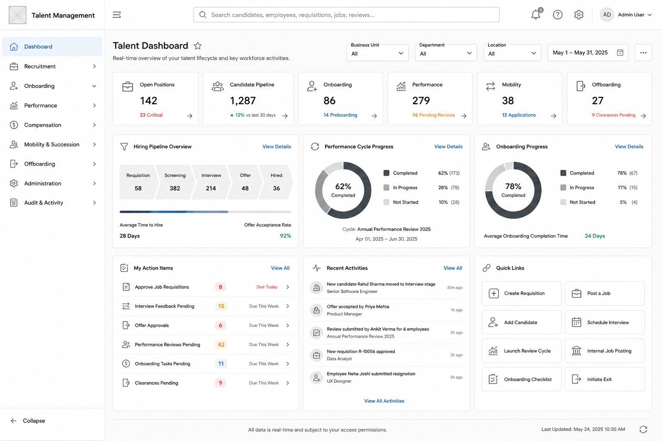

Screen 2 — Recruitment & ATS Center

Purpose

Manage everything from requisition to hire.

Covers

Requisitions

Raise requisition

Approvals

Headcount requests

Job Openings

Publish jobs

Internal jobs

External jobs

Candidate Pipeline

Applications

Screening

Interviews

Offers

Interview Management

Scheduling

Panels

Scorecards

Offers

Approval

Negotiation

Acceptance

Views

Table

Kanban

Calendar

Primary Users

HR Manager

Department Head

Candidate

Wireframe

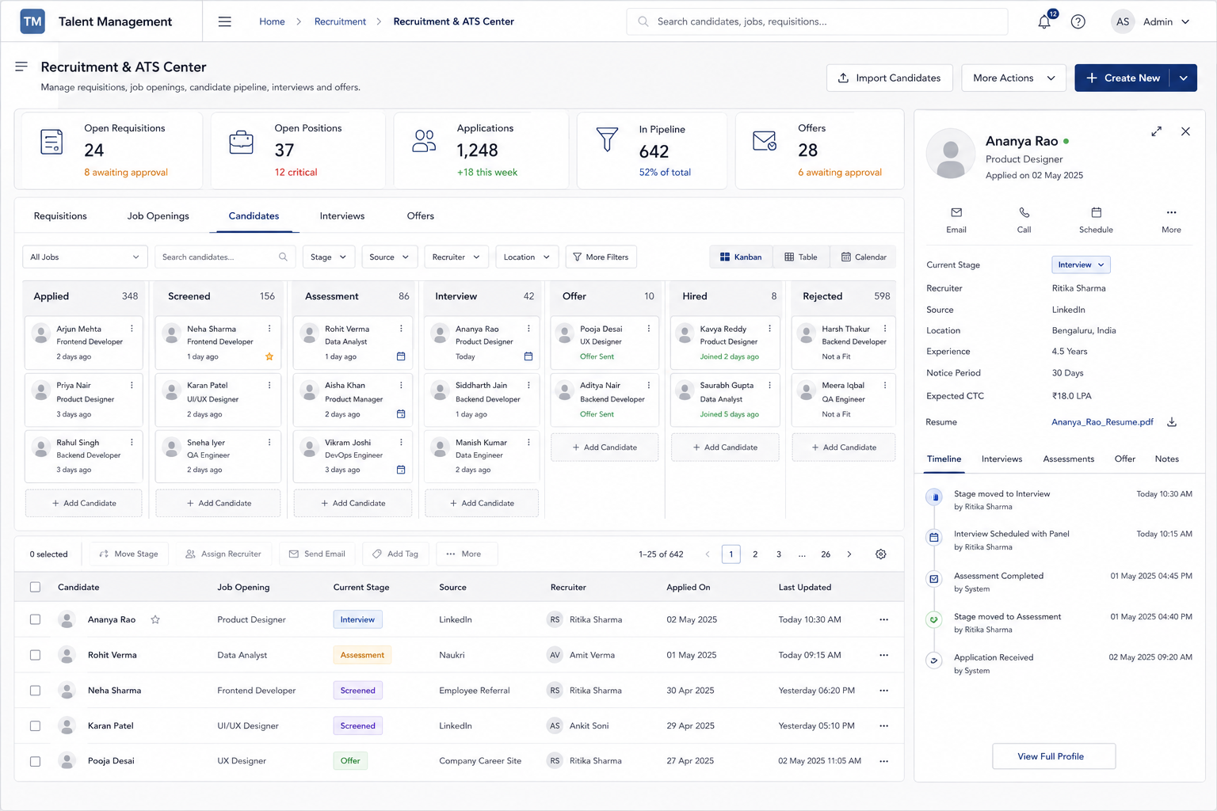

Screen 3 — Candidate & Employee Talent Profile

Purpose

Single detailed profile throughout lifecycle.

Candidate becomes Employee without changing experience.

Candidate Section

Resume

Application history

Interviews

Assessments

Offer

Employee Section

Position history

Goals

Reviews

Compensation

Mobility

Succession

Documents

Views

Overview

Timeline

Documents

Activity

Primary Users

HR

Department Head

Employee

Wireframe
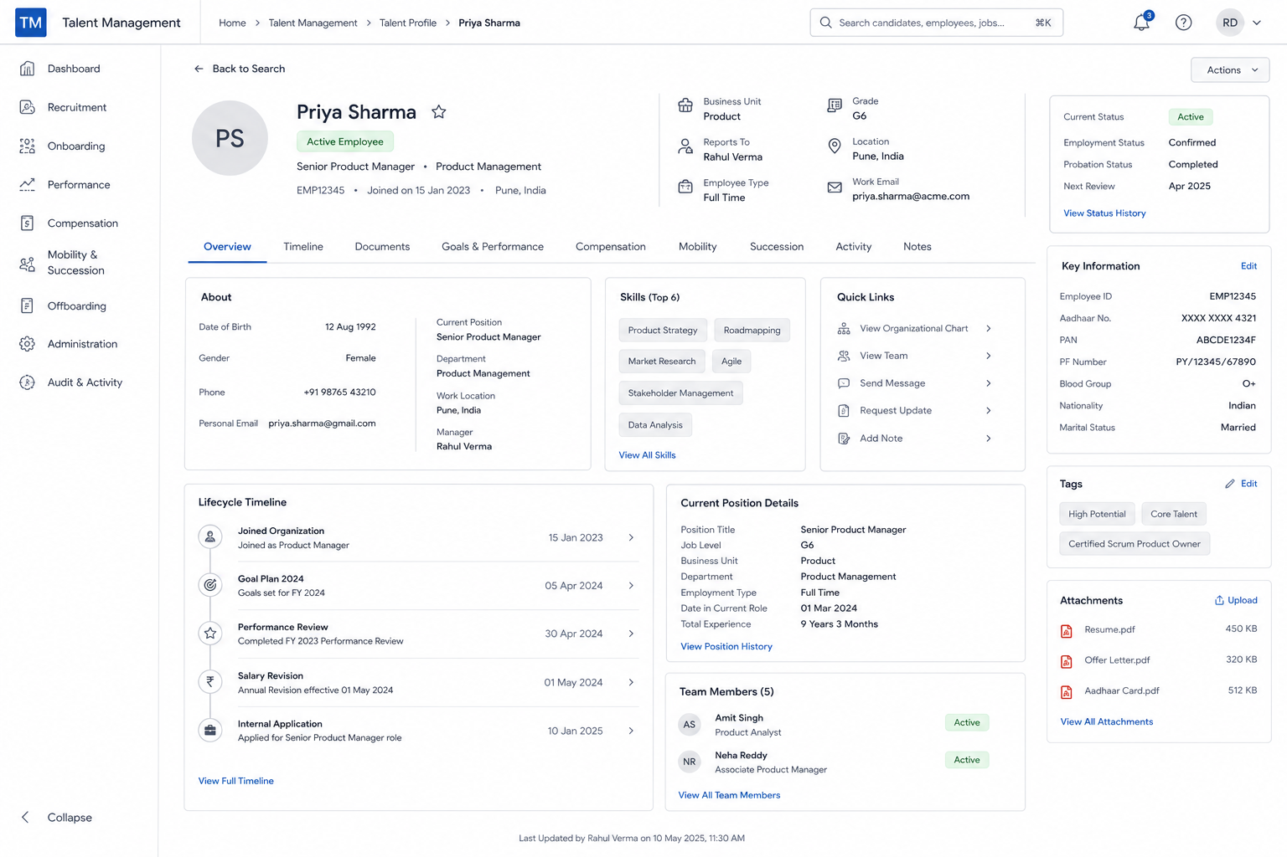

Screen 4 — Onboarding & Employee Lifecycle Center

Purpose

Manage employee entry into organization.

Covers

Preboarding

Documents

Compliance forms

Onboarding

Joining checklist

Buddy assignment

Equipment allocation tracking

Probation

Milestones

Confirmation workflow

Views

Progress Tracker

Checklist View

Timeline View

Primary Users

HR

Manager

Employee

Wireframe
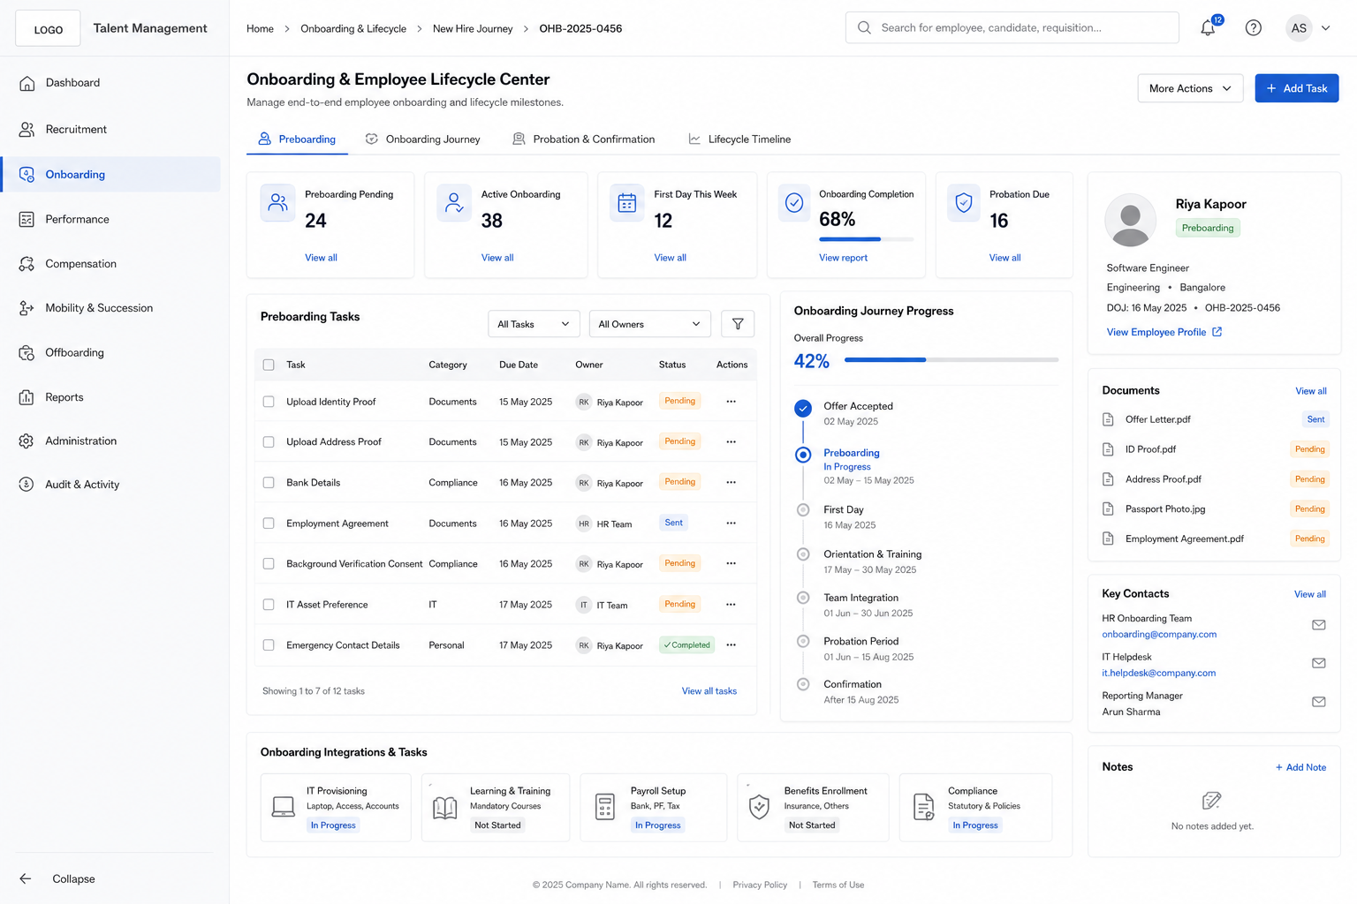

Screen 5 — Performance & Rewards Center

Purpose

Manage goals, reviews, ratings and reward decisions.

Covers

Goals

Goal setting

Goal cascading

Performance Reviews

Self review

Manager review

Calibration

Appraisals

Ratings

Recommendations

Compensation

Increment recommendations

Bonus recommendations

Reward statements

Views

Review Board

Employee List

Cycle Timeline

Primary Users

Employee

Manager

HR

Executives
Wireframe

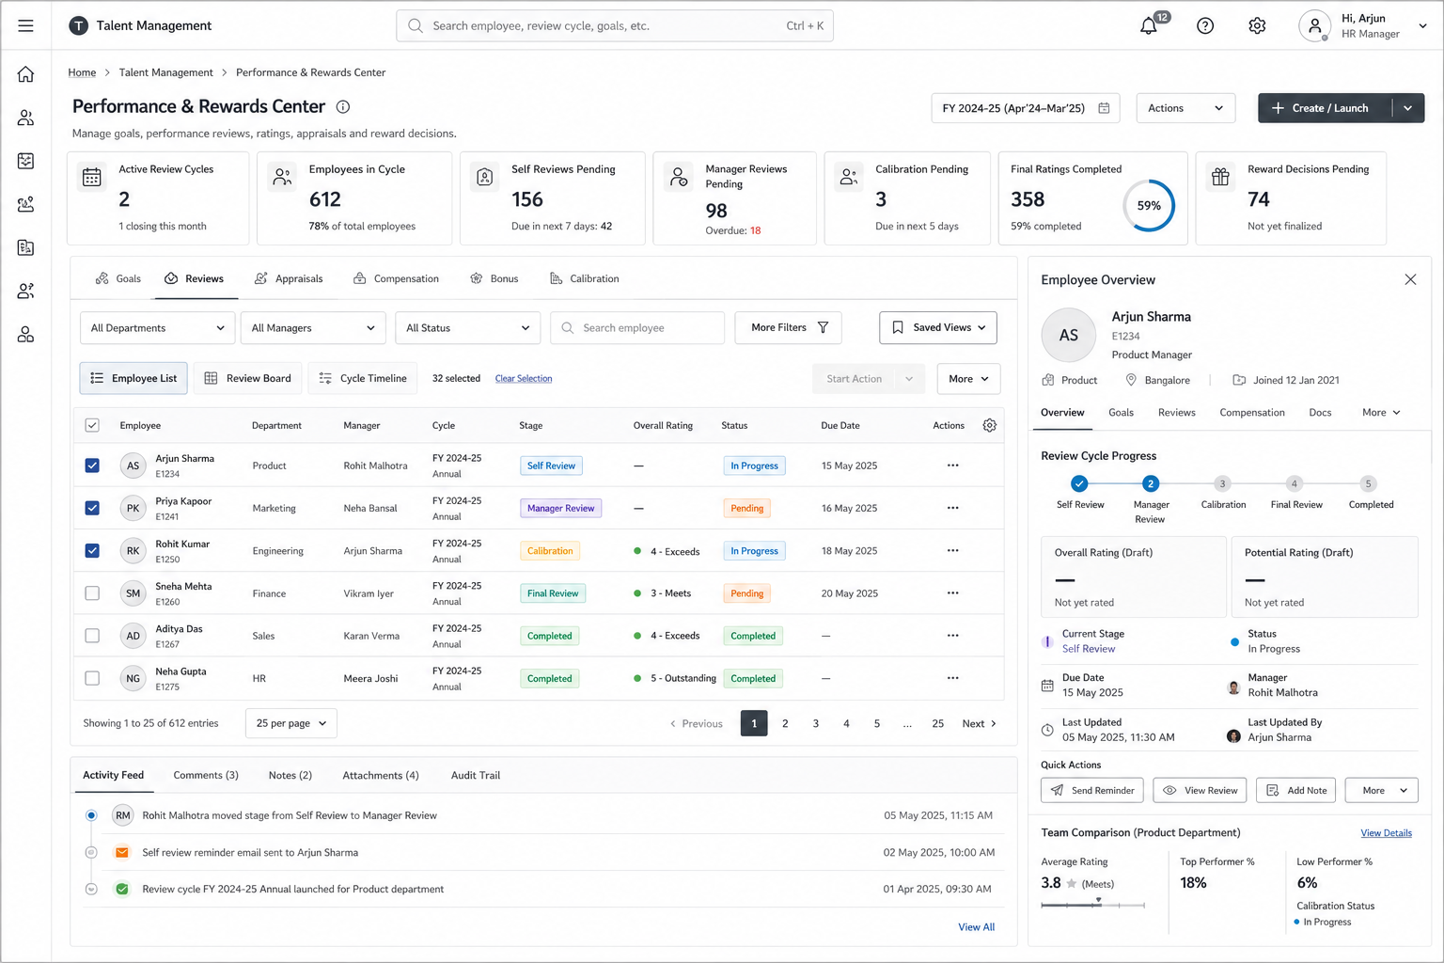

Screen 6 — Internal Mobility & Succession Center

Purpose

Manage talent movement and future leadership.

Covers

Internal Jobs

Internal postings

Applications

Transfers

Department moves

Location moves

Promotions

Promotion recommendations

Approvals

Succession

Critical roles

Successor pools

Bench strength

Views

Position View

Succession Tree

Talent Pool Board

Primary Users

HR

Department Head

Executives

Employees

Wireframe

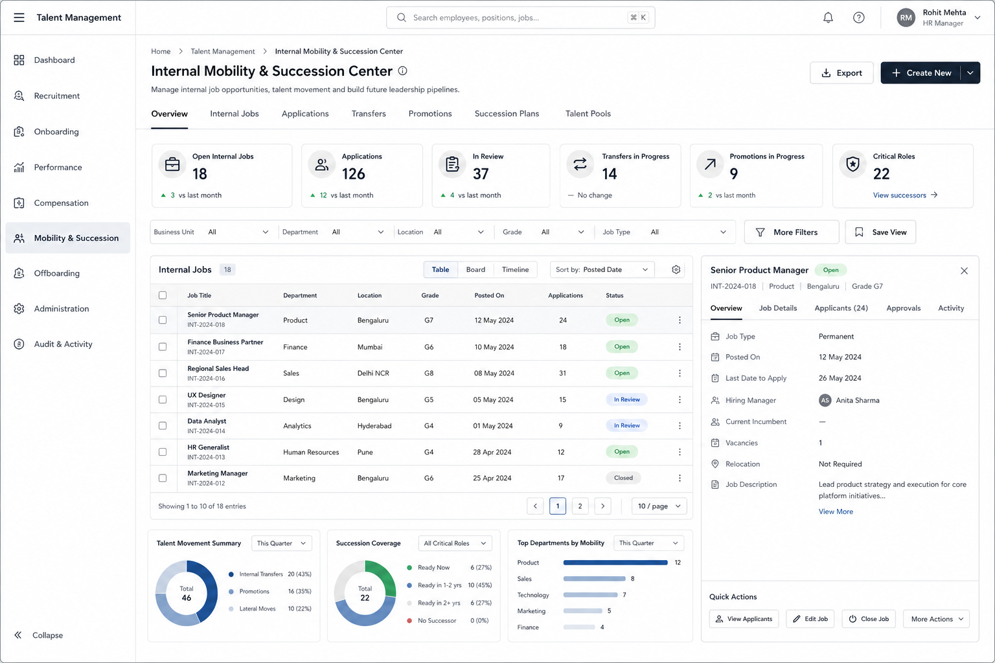

Screen 7 — Offboarding Center

Purpose

Manage resignation through exit completion.

Covers

Resignation

Submission

Acceptance

Knowledge Transfer

Handover plans

Clearance

IT

Admin

Finance

Exit

Interview

Rehire eligibility

Views

Exit Pipeline

Clearance Tracker

Checklist View

Primary Users

HR

Manager

Employee

Wireframe

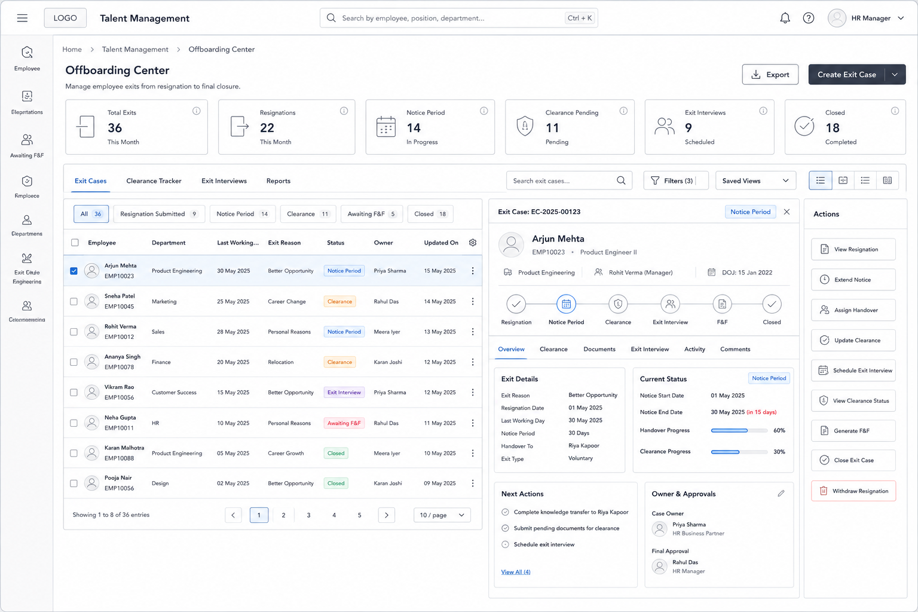

Screen 8 — Administration & Governance

Purpose

All configurations in one place.

Covers

Talent Configuration

Workflow setup

Approval chains

Templates

JD templates

Interview scorecards

Offer templates

Review forms

Permissions

Roles

Access controls

Integrations

LMS

Competency

Payroll

Job Boards

Audit

Change history

Version history

Primary Users

Admin

HR Admin

Wireframe
